RSPP
Working Paper

Type Title Here. The Style is Named Paper Title

First Name LAST NAME
First Name LAST NAME
First Name LAST NAME
2020 – ISSUE – Nº

Disclaimer: This paper should not be reported as representing the views of the Regional Science Policy & Practice (RSPP). The views expressed are those of the authors and do not necessarily reflect those of the RSPP.

Type Title Here. The Style is Named Title
By First Last and First M. Last, the Style is Named Author
Abstract
Type the text here. The style is named Normal for regular paragraphs. Type the text here. The style is named Normal for regular paragraphs. Type the text here. The style is named Normal for regular paragraphs.
Keywords
Minimum 3 keywords. The style is named Normal for regular paragraphs.

First Level Heading – The Style is Named Heading 1
Type the text here. The style is named Normal for regular paragraphs. Type the text here. The style is named Normal for regular paragraphs. Type the text here. The style is named Normal for regular paragraphs.

Second Level Heading – The Style is Named Heading 2
Type the text here. The style is named Normal for regular paragraphs. Type the text here. The style is named Normal for regular paragraphs. Type the text here. The style is named Normal for regular paragraphs.

Third Level Heading – The Style is Named Heading 3
Type the text here. The style is named Normal for regular paragraphs. Type the text here. The style is named Normal for regular paragraphs. Type the text here. The style is named Normal for regular paragraphs.
Type the text here. The style is named Normal for regular paragraphs. Type the text here. The style is named Normal for regular paragraphs. Type the text here. The style is named Normal for regular paragraphs.
Equation, (1)
where …
Equation. (2)
The style is named Normal after an equation.

Footnotes
Insert footnotes as necessary using the Insert | Footnote menu item in Word 2003 or the References | Insert Footnote ribbon item in Word 2007.The footnote number in the text is formatted automatically. An area for the text for the footnote appears at the bottom of the page and is formatted automatically.

List Styles
Examples follow for bulleted and numbered lists.
- This is a bulleted list. Only one level is generally used.
- The style is named List Bullet.
- This is a bulleted list.

- This is a numbered list. Only one level is generally used.
- The style is named List Number.
- This is a numbered list.

Figures
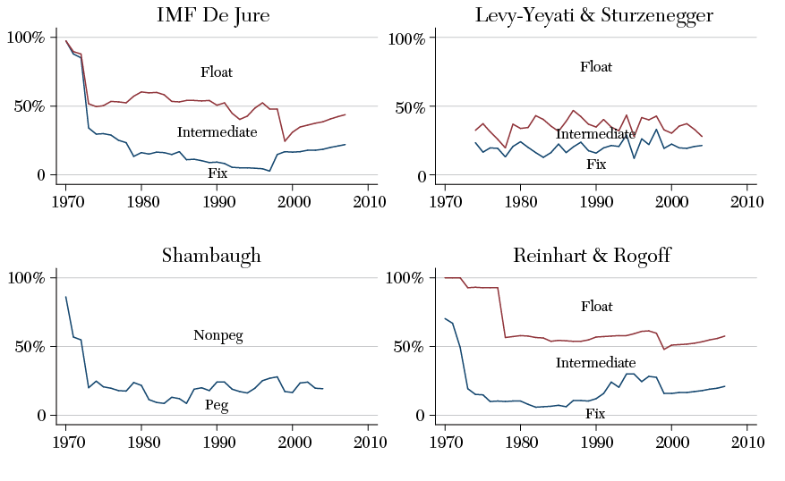
Figure 1. The Title of the Figure. The Style is named Figure Title
Notes: These are the notes applicable to the figure. The style is named Figure and Table Notes.

Tables
TABLE 1. The Title of the Table, The Style is Named Table Title
 | 1948–2007ª | 1948–1972 | 1973–1994 | 1995–2007
Panel A. The style is named Table Text
Tangible | 11.4* | 11.2 | 12.3 | 10.4
Intangible | 8.6 | 5.9 | 9.2 | 12.8
Panel B. Share of capital input
Tangible | 76.2 | 82.6** | 74.8 | 66.1
Intangible | 23.8 | 17.4 | 25.2*** | 33.9
Notes: These are the notes applicable to the table. The style is Figure and Table Notes. a Applicable to the whole period. The style is named Figure and Table Notes. *** Significant at the 1 percent level. The style is Figure and Table Notes. ** Significant at the 5 percent level. * Significant at the 10 percent level.
Source: Author calculations. These are more table notes. The style is Figure and Table Notes.

REFERENCES
Reference List
- Authors – Family Name and initials
- With space between initials in given Names
- Initials have full stops.
- Multiple authors separated by a comma
- Use “&” before last author with preceding comma
- Use “(Ed.)” or “(Eds.)” to denote editors
- List only up to 7 authors. If more than 7 authors, list first 6 authors, then ellipses followed by the last author.
- Article title in sentence case, but initial caps for first word after colon
- Journal titles are written in full
- For editions, use “(2nd ed.)”, “(3rd ed.)”, and so forth [follow existing journal style for superscripting of ordinal indicators]
- Page ranges are written in full
- For page ranges and page count, use “p.” for single page and “pp.” for multiple pages and page ranges
- Formatting: journalTitle and bookTitle in italics. Volume in italics as well. As a general rule, for non-journal or book references where there appears to be 2 titles: one appearing to be a part of the other larger body of work, set the larger body of work in italics. In this case, italic tags will need to be added, as only journalTitle, bookTitle, or bookSeriesTitle will be formatted by the template.
A sample reference is shown below.
Last, F., & LAST, F. (2003). Article Title. Full JournalTitle, volume(issue), pages.
Author(s). (Year of publication). BookTitle (Edition of book if later than 1st ed). Place of publication: Publisher Name.
[The style named is References].

Examples
Journal Articles | Author(s). (Publication year). ArticleTitle. Full JournalTitle, volume(issue), pages.
One author | Fawcett, T. (2006). An introduction to ROC analysis. Pattern Recognition Letters, 27(8), 861–874. DOI: 10.1016/j.patrec.2005.10.010. | Issue number is optional. Use issue only if each issue starts at page 1. If pagination is continuous within volume, use volume only.  Do not add punctuation after DOIs and URLs.
2 to 7 authors | Daley, C. E., & Nagle, R. J. (1996). Relevance of WISC-III Indicators for assessment of learning disabilities. Journal of Psychoeducational Assessment, 14(4), 320–333.  Ramus, F., Rosen, S., Dakin, S. C. Day, B. L., Castellote, J. M., White, S., & Frith, U. (2003). Theories of developmental dyslexia: Insights from a multiple case study of dyslexic adults. Brain, 126(4), 841–865. DOI: 10.1093/brain/awg076
More than 7 authors | Rutter, M., Caspi, A., Fergusson, D., Horwood, L. J., Goodman, R., Maughan, B., … Carroll, J. (2004). Sex differences in developmental reading disability: New findings from 4 epidemiological studies. Journal of the American Medical Association, 291(16), 2007–2012. DOI: 10.1001/jama.291.16.2007
In press or forthcoming | van Bergen, E., de Jong, P. F., Maassen, B., Krikhaar, E., Plakas, A., & van der Leij, A. (in press). IQ of four-year-olds who go on to develop dyslexia. Journal of Learning Disabilities. DOI: 10.1177/0022219413479673

Books | Authored:  Author(s). (Year of publication). BookTitle (Edition of book if later than 1st ed). Place of publication: Publisher Name.  Chapter in a Book:  Author(s). (Year of publication). ChapterTitle. In Editor(s) (Eds.), BookTitle (Edition of book if later than 1st ed). (pp. pages). Place of publication: Publisher Name.
Personal author(s) | Beck, I. (1989). Reading today and tomorrow: Teachers edition for grades 1 and 2. Austin, TX: Holt and Co.  Bradley, L., & Bryant, P. (1985). Rhyme and reason in reading and spelling. Ann Arbor: University of Michigan Press.  Howell, K. W., Fox, S. L., & Morehead, K. W. (1993). Curriculum–Based evaluation: Teaching and decision making (2nd ed.). Pacific Grove, CA: Brooks/Cole Publishing Company. | For publisher location, if US city, give city, followed by 2-letter postal abbreviation for state, unless the state is already included in the publisher name. For non-US cities, give the city and country in full.
Chapter in Edited Book | Borstrøm, I., & Elbro, C. (1997). Prevention of dyslexia in kindergarten: Effects of phoneme awareness training with children of dyslexic parents. In C. Hulme & M. Snowling (Eds.), Dyslexia: Biology, cognition and intervention (pp. 235–253). London, UK: Whurr.

Conference Papers | Author(s). (Year/Date of conference). OtherTitle. Paper presented at Conference title, conference location.  Author(s). (Year). OtherTitle. In OtherTitle, pp. pages.
Conference Paper | Balakrishnan, R. (2006, March 25-26). Why aren't we using 3d user interfaces, and will we ever? Paper presented at the IEEE Symposium on 3D User Interfaces. DOI:10.1109/VR.2006.148  Fan, K. Y. (1986, September). Graphic symbol of the Chinese character. Paper presented at the meeting of the Symposium of Chinese Character Modernization, Beijing, China.
Conference Proceedings | Rapp, R. (1995). Automatic identification of word translations from unrelated English and German corpora. In Proceedings of the 37th Annual Conference of the Association for the Computational Linguistics, pp. 519–525.  Argamon, S., & Levitan, S. (2005). Measuring the usefulness of function words for authorship attribution. In Proceedings of the 2005 ACH/ALLC Conference. Victoria: Canada. Retrieved from http://citeseerx.ist.psu.edu/viewdoc/summary?doi=10.1.1.71.6935 | Use “Retrieved from” to indicate online sources.

Other reference types
Scientific or Technical Reports | NICHD. National Institute of Child Health and Human Development (2000). Report of the National Reading Panel. Teaching children to read: An evidence-based assessment of the scientific research literature on reading and its implications for reading instruction (NIH Publication No. 00-4769). Washington, DC: U.S. Government Printing Office.
Dissertation | van Otterloo, S. G. (2011). Early home-based intervention for children at familial risk of dyslexia. University of Amsterdam (unpublished doctoral dissertation).  Eleveld, M. A. (2005). At risk for dyslexia. The role of phonological abilities, letter knowledge, and speed of serial naming in early intervention and diagnosis (PhD thesis). State University Groningen, The Netherlands. Leuven: Garant Publishers.
Personal Communication | Not allowed in reference list. Cite in text only.

Place the contact information and acknowledgments for the paper here. The correct format is: Name, Affiliation, Mailing Address, City, Country (e-mail: name@domain.edu). Acknowledgments: The style is named Contact.
Type the footnote here. It is automatically formatted to the correct style.

